Project Report

* About this Project

Privacy protection

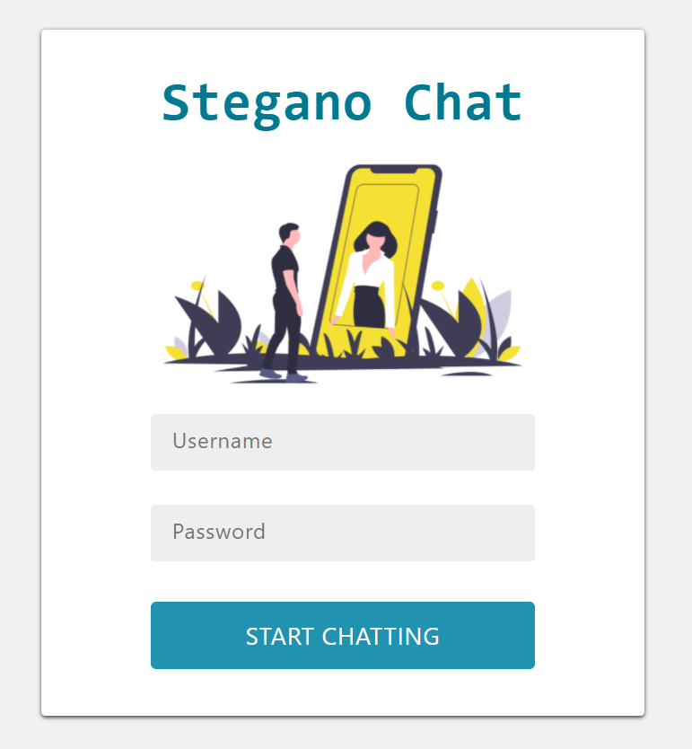

**Chat feed**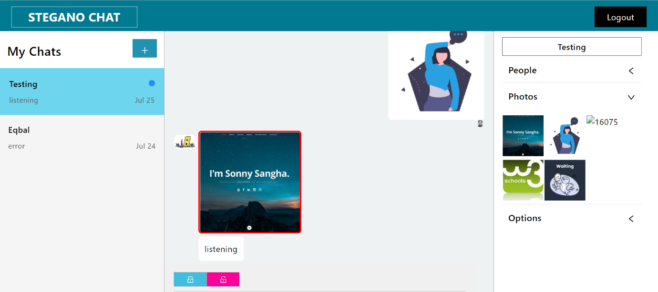

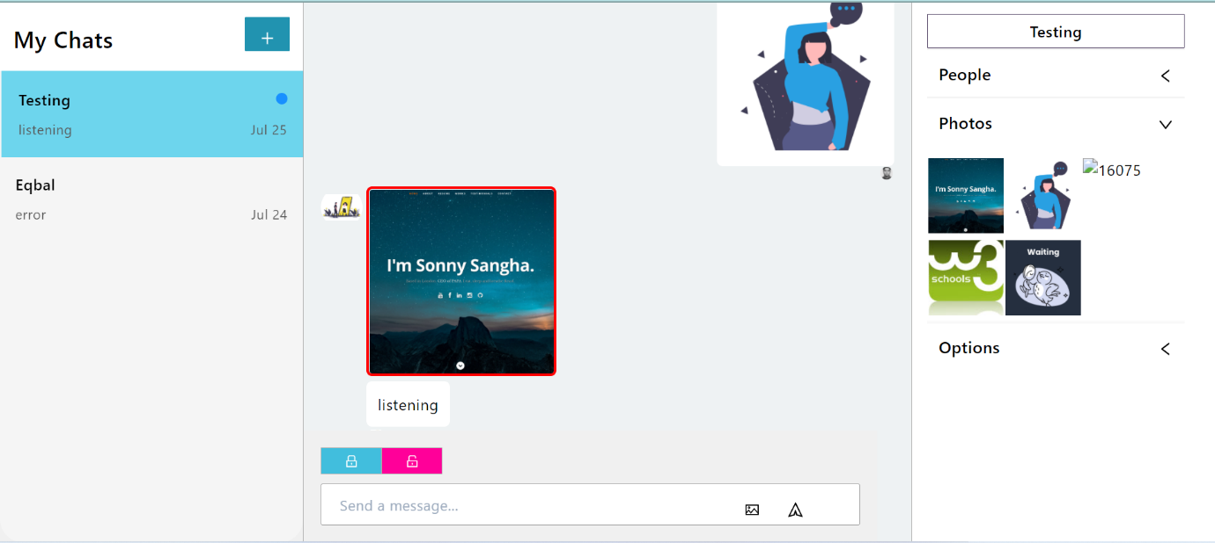

**Encryption:**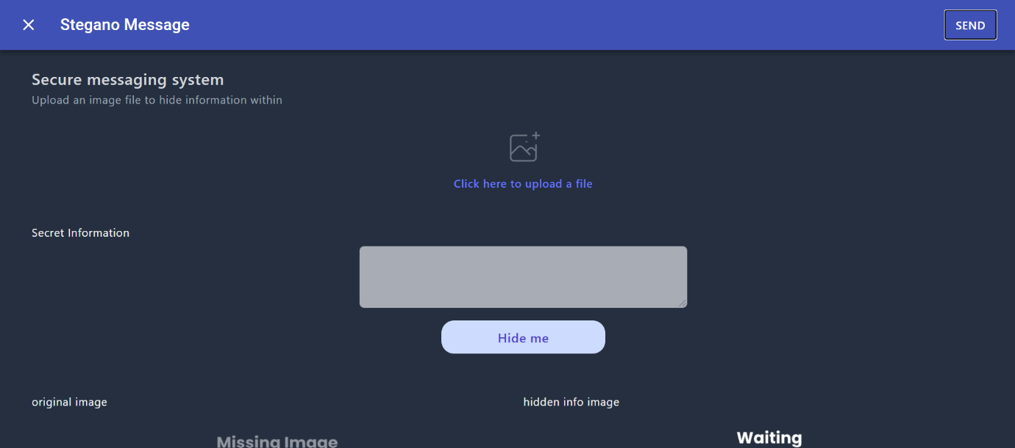

**Decryption:**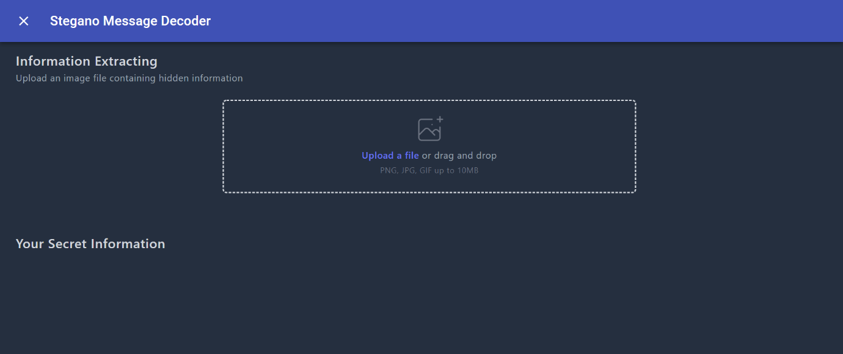

* Problem statement :--
* an open source messaging system for secure secret transmission, with privacy protection feature. It is powered by image steganography.
* **Built With**

We built our project using:-

>>React

>>API call from Chatengine.io

>>NPM

>>tailwind

* Objectives

First we had come up with an idea to make the chat app where we could hide the message so that only user could have the key to unhide those message and then this idea break through our mind to hide the text in image itself and that’s how we pumped up making this stegano-chat app

* **Approach**

Basically, the problem statement is to make a chat app which could also be used as to send a hidden message encrypted in a image with privacy protection feature

We made this chat app using react with the help of chatengine.io which is working on backend part and then we added the facility to send image and encrypt image and to decrypt image which carries a JavaScript function and for outer UI improvisation we tailwind.